GlyphScribe AI

Name : Aarush
Candidate NO: 9193
Centre NO: 33611

Table of Contents
Analysis 3
INTRODUCTION 4
Defining the problem: 4
Aim: 4
Suitability 5
Research 6
Already existing solutions: 6
Primary data collection : 8
Client interview 12
Programming lang 14
Hardware & Software Requirements 15
Limitations 16
Requirements specification & Success criteria 17
Design 19
Decomposition of the problem : 20
Defining the Structure: 23

Analysis

INTRODUCTION

Defining the problem:
Recently, technology has had an exponential increase in popularity and people are moving to digital solutions for almost everything and with people moving away from paper based infrastructure and towards digital documents.
This advancement has had many benefits but lead to the development of social media and other distractions from the . One of the main icons in modern computing is AI which not a modern concept of machines learning from data and creating a solution – from the perceptron which was designed and worked in 1943 with the first signs of neural networks showing through- however machine learning models have not been as widely used until recently as originally the models had no real user friendly way to interact with them and only enthusiasts and people who could interact with them could use them to the full capacity. In modern computing, neural networks are used widely for data analysis and image processing.
My client’s name is Manish , he works as a radiologist and needs a way to digitally note his numerical notes on dosage or vitals of a patient (so he can access them anywhere), which take up a lot of time that he could spend on more reports and increase efficiency of his day. He has looked at many solutions in the past such as the machines automatically giving him a digital version of all the data but it us very expensive. My project will be able to help him by : detecting the handwritten numbers ; convert them to digital text that can be copied and pasted ; improve the accuracy of the patient records; provide faster results and more reliable data .

Aim:
The aim of this project is to create a model that can recognise a singular number from handwriting and output it as text, this will be done using Pytorch, my code will consist of many programming techniques such as tensor manipulation , computer vision, running tests for many epochs to cater the model specifically for its use case here and I will also need to make a graphical user interface for the program. The program will be catered towards students and employees who want to convert their handwritten notes into text. This tool is targeted towards those who want to store their handwritten data online in the places such as the cloud (it can be accessed anywhere with internet access) but find it helpful to write things on paper to improve the retention of information in their brain as writing triggers an area of the brain called the hippocampus which plays a large factor in long term retention.

Suitability

Thinking about the suitability of this idea (why a computer is needed to solve it ), the predominant factor is the speed and efficiency of a computer vs. a human as the computer can fetch decode and execute data much faster than a human mind can think and manually type data out – considering this is data that they have already written it may be tedious to copy that down for the sole reason of storing it to be edited and stored online or in a cloud platform e.g. OneDrive – would mean that a machine would be able to perhaps automate this process so that the client can focus on other things , maximising productivity .
Another key factor is the accuracy and consistency of the computer, which eliminates human errors and possible redundancies such as copying a character wrong or even having poor eyesight. Once trained, the model can consistently and efficiently apply this concept to large scale projects such as in schools – transcribing large volumes of data ( like hundreds of exams scores or forms ) in which case automation is essential .
This concept is already widely used across may industries such as postal services like Royal Mail who utilize the program to read the handwritten postcodes on envelopes or even hospitals who use it to transcribe handwritten forms with patient ids and credentials securely and accurately (as there is no liability in terms of human interactions ) directly into their database : this illustrates how this program is already being applied to real world cases and is suitable in almost all industries.

Research

Already existing solutions:
https://www.youtube.com/watch?v=vBlO87ZAiiw&t=11s
https://github.com/jc639/pytorch-handwritingCTC
Example Solution 1:
CTC Handwriting model:
This project was written in Pytorch and is a great example of what I want to achieve, it has the same idea as my project but with a greater level of complexity. The basis of this project is a Convolutional Neural Network as it is ideal for analysing visual imagery and content detection through the kernels (filters applied to the convolutional layers). One thing that I think this project does well is the deslant algorithm written in OpenCV, this is very useful as it abstracts the slant factor out of the input into the specialized CNN and so allows for a more accurate output. One draw-back of this is that it uses the IAM dataset (Contains handwritten forms with sentences, phrases and words and digits 0 to 9 and other features irrelevant to digit recognition)– and when out of the box this doesn’t really haver much accuracy – which requires the model to have a certain amount of pretraining before being functional. To fix this I will most likely use something like MNIST dataset from Kaggle.com which is more suitable as it contains 70,000 greyscale images of handwritten images of handwritten digits and they are pixelated which makes it easier to input into the neural network as a weighted sum and exclusively is focus on digits.
Below I have shown trial runs of the code:

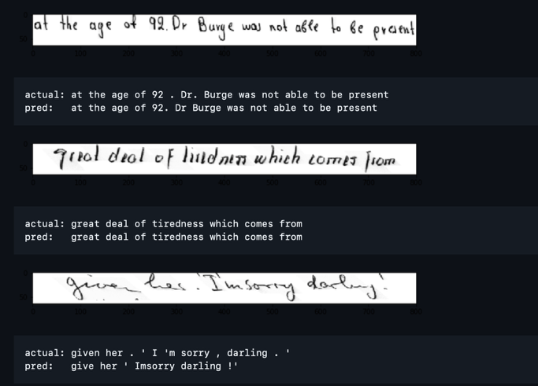
Figure 1 - tests of CTC

This project was found on git hub was written by “jc6 39 ” _ here’s the link to the project
https://github.com/jc639/pytorch-handwritingCTC

Example solution 2:
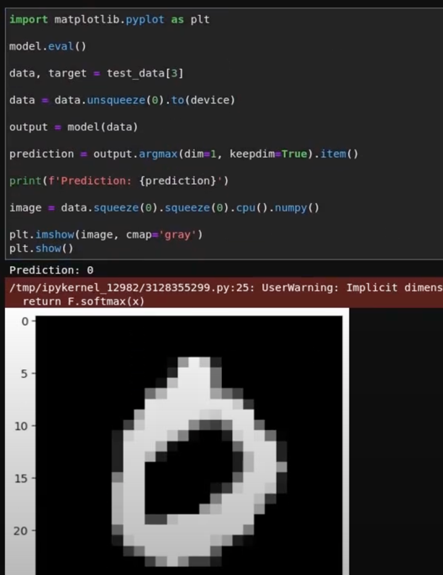
In this second project we start with a basic CNN and train it with the MNIST dataset to recognise digits. This has a more lightweight and portable design ensuring a more universal model that can run on almost any CPU or GPU. The use of this pre trained model significantly reduces development time as the training would take 30-40 minutes using GPUs provided by Google Collab or 4-6 hours on an average CPU, this allows the developer to spend less time interacting and debugging the initial CNN, this is also thanks to the simpler two layer convolutional model. However there are some drawbacks :
Figure 2 - neural 9's example
- The MNIST dataset is used meaning only single digits images shown in Figure 2 can be processed, compared to the IAM dataset which can handle multidigit and word computation
- It also lacks a UI meaning it isn’t as accessible to others that aren’t in the field

This second project was found on Neural nines YouTube channel. Heres the link:
https://www.youtube.com/watch?v=vBlO87ZAiiw&t=11s

Methodology:
The methodology i will be implementing is the waterfall methodology as it allows me to work on larger scale projects due to the loops in the methodology ( if the test fails I go back up to the analysis and design and then code it ). I think it also makes it clear and concise to document

Primary data collection :
- I collected my primary research via the means of a Microsoft Form with 17 responses and questions that have targeted questions about the functions of the project. The main limitation here is that I couldn’t
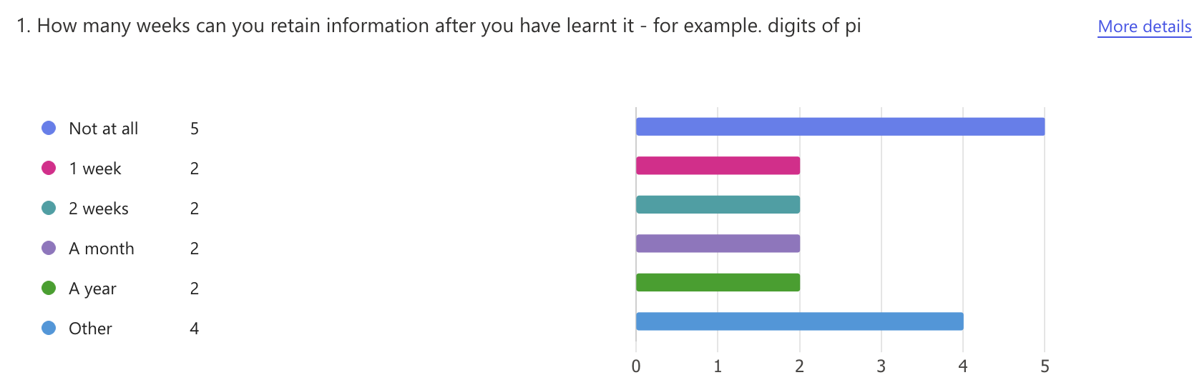
Figure 3 - Quesion 1
This question was relevant to obtain context to how many people would use the program and highlights why it is important to make this program and its real world application as over 50% of replies said that they can’t remember much numerical info for under a month , - which is when you consider it in the transition to long term memory, this project will aid these people in storing the handwritten data (which is almost one time use and doesn’t see the light of day again ) by transcribing it into digital editable text which could be stored in cloud platforms for use anywhere in the world with internet connection.

Question 2 .
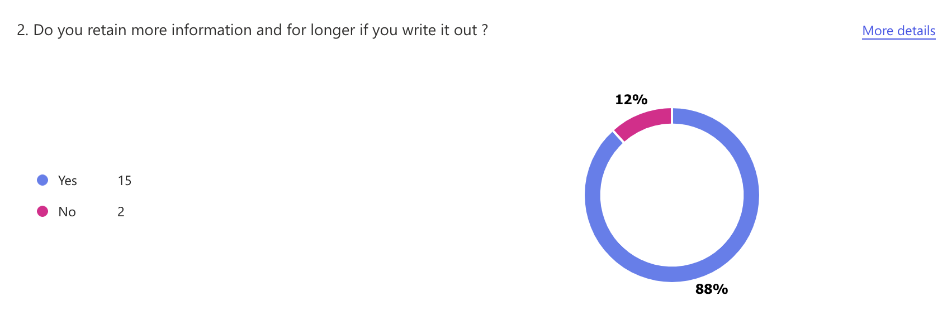
Figure 4 - Question 2
Here a key point is brought to light, the results of this question show that, writing key points aids in imbuing them into people’s long-term memory – as shown in Figure 4, and that skipping that step and just typing it out would mean a reduction in cognition and longevity of the information stored in the client’s mind. This confirms the idea that my program would be useful as the client can write the data down (this step adds and consolidates the data into the clients memory) and then convert it to editable digital text (so they can store it online) which would aid when recalling it .
Question 3 .
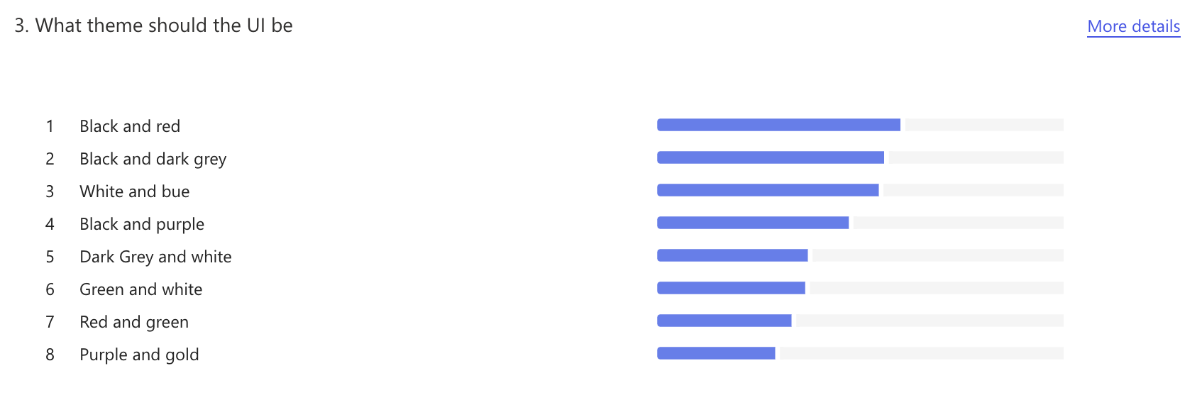
Figure 5 - Question 3
Question 3 was focused on the user experience. Respondents ranked the themes for the user interface with the darker aesthetic being dominant over other choices with a 3:1 ratio occurring with darker hues to lighter hues. It is clear that a darker aesthetic would be favoured, possibly due to the fact that it creates a welcoming tone and is easy on the eyes .

Question 4 .
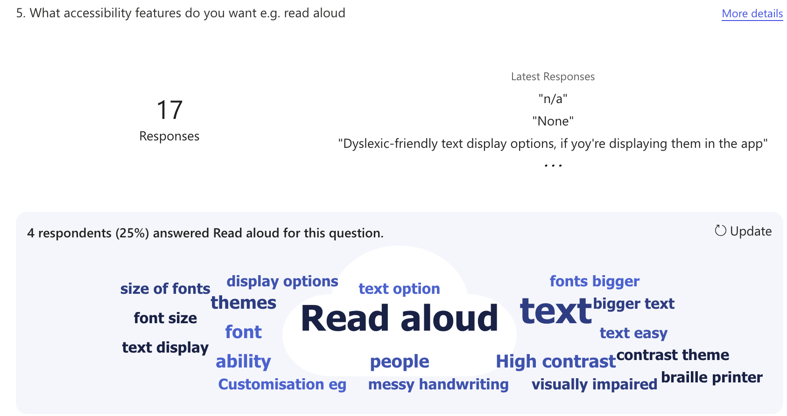
Figure 6 - Question 4
Question 4 was a text input based question on the accessibility features that should be included to increase inclusivity so that everyone has access to the tool , this is key as there are other use cases for the numbers to text converter (e.g. a visually impaired client person taking a picture of maths and the program outputs it as audio ). The responses given provide an overview of the things that should be included to increase accessibility. With 25% of respondents wanting the read-aloud feature , and a high-contrast feature being a popular concept too, although this is a great feature I think it would over complexify the code and be outside the scope of the objective.
Question 5 .
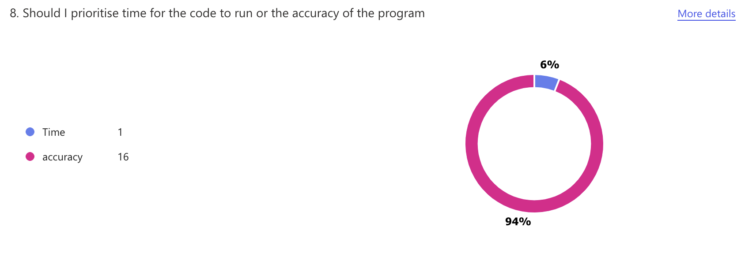
Figure 7 - Quesion 5
This question was a selection between runtime and accuracy of the outputs , I wanted to find out what was more important for the client as for tasks requiring a more real- time transcription the time to run should be reduces which may reduce the accuracy as less compute time meaning less iterations of the program should be ran. Whereas, if you prioritise accuracy , many iterations of the code can be run and the mode would be used for a more accurate output.
Question 6 .
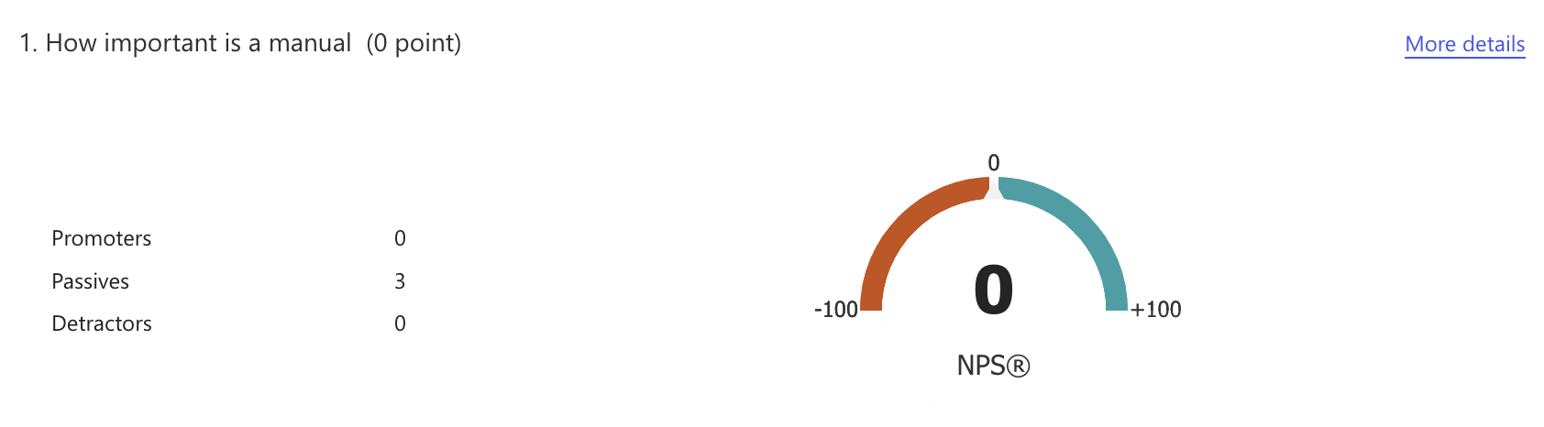
Figure 8- Question 6
I specifically chose this question to gauge how intuitive the responders think that the program will be, the results imply that it should be quite intuitive already as it is quite simple in the frontend, but to make sure that the client understands what to do. I will include a markdown file for the user to get started.
Question 7.
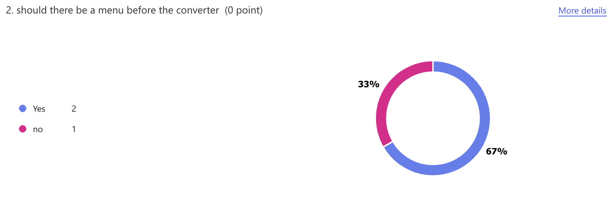
Figure 9 - Question 7
This question presented the idea of a menu to before the main program and the results tend towards the “ Yes ” option. In my opinion this would be great but due to time constraints and testing it wouldn’t be ideal as when testing I would have to go through the menu to test the functioning of the code and even when debugging which would massively increase time to test and adapt (the period of time when I should be almost iterating through the project , testing to find erroneous outputs ), so this will only be included if I have spare time at the end of the project. However I will try my best to add it within the time frame
Question 8 .
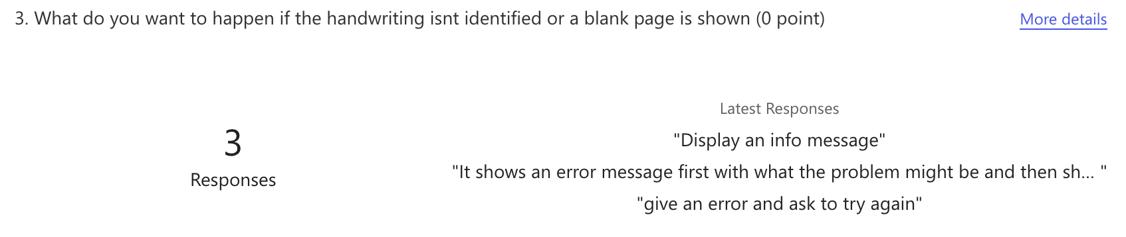
Figure 10- Question 8
For Question 8 a range of suggestions were given for how the program would handle erroneous data. However , one response caught my eye the most “It shows an error message first with what the problem might be and then shows how to improve the legibility/ ease of transcription e.g. Put the text into better lighting.”, the respondent gave a detailed response with a great idea of telling them to place it in better lighting or on a background with sharper contrast , this would increase the accuracy of the prediction by a lot.

Client interview
After looking at the survey, I think I will need more detailed information to create a project that caters for the client’s needs. To gather this, I conducted an interview with Manish Kumar (MK) concerning the expectations he has for this :
Me : I understand that you are a radiologist and want my model to digitize your notes, tell me more specific use cases that you might do ?
MK: Yes , I handle patient reports and jot down statistics like their vitals and dosages of medicine patients will receive and manually doing this takes 5-10min each per patient, I want to automate this process so I can easily copy and paste them into the health database, it would be great if you could do this on my laptop
Me: Thanks for the information, would you like to convert more than one digit at once?
MK: Hmm. Not really, I will only need up to two digit numbers as they are usually percentages or dosages that are usually two digits, If needed I can do this operation twice for the patient details as the date of birth can be split into 3 separate sections
Me: That’s great, ill implement multi character support and collate them to show the digit all together. In terms of the input what colour of paper do you use as it may reduce contrast and make a less accurate output if the image is blurry or unclear?
MK: I usually write on white paper with no lines on my notepad or ill use the paint application on my tablet, which has a black background.
Me: That sounds great , just make dure to use a back pen on the paper to get the best contrast, but do you have good internet connection where you are as I will be using Google Collab which connects to a GPU via the cloud.
MK: Yes my office has great connection as it has a fibre optic connection supplied by BRSK and is usually 500 mbps on average
Me: Yeah , you’ll definitely be fine in terms of internet connection. In terms of the process after you transcribe the data, what do you want to do?
MK: Umm… I think it would be ideal if I could copy the number directly only onto my clipboard, could you make this automatic
Me: That will make things easier for the users, and is easy to integrate uising pyperclip
Me: Dr. Manish, given that these notes contain patient data do you want to tore them on a text file or do you want to delete them after use?
MK: Personally I think that the data is already pretty secure on out network as we have professionals in cybersecurity employed at our radiology clinic to manage that but I think it would be great if you could store them on an excel spreadsheet.
Me: That’s great. i’ve never used the integration with Excel but it doesn’t seem too hard let me do some research quickly:
Me: Yeah that shouldn’t be too difficult thanks to the xlswriter module like this
import xlsxwriter
workbook = xlsxwriter.Workbook('path_to_hello.xlsx')
worksheet = workbook.add_worksheet()
worksheet.write('A1', Num 1')
worksheet.write('B1', 'Num 2')
workbook.close()
from: https://www.geeksforgeeks.org/python/python-create-and-write-on-excel-file-using-xlsxwriter-module/
Me: Alright Dr. Manish, that should be all for the questions, it was really great to sit down and talk to the client so I can make the program specific to your needs.
MK: No worries , I’m excited to see the product .

Programming lang
Having considered languages such as TensorFlow , I have decide to use Pytorch for my project as it has a more gradual learning curve and is the most common language for artificial models. It is also great as I already have some prerequisites such as basic manipulation and other functions in Pytorch, I also have 5 years of experience in the python ecosystem with many projects using the different modules such as pygame , and NumPy. However, I initially don’t have much experience with CNNs and training them with datasets.
For the GUI I will be using Streamlit which is a platform that easily integrates with Pytorch and Streamlit allows you to easily deploy applications.

Hardware & Software Requirements
I am using Pytorch on Google Collab which doesn’t need much local compute power as you can connect to a GPU via the cloud but here are the client’s specs
Specs. | Client Device
Storage | 250 GB free (HDD)
RAM | 8GB
Operating system | MacOS
Processor | 2.3 GHz Quad core Intel i5
Screen res | 2560x1600

These specs are more than enough of this use case and the client also has fibreoptic connection which allows fast connection to the GPUs provided by Google Collab

Limitations
In terms of limitations, the most prevalent being the time constraint as I will only set myself 6 months as my deadline to finish this project, after this date I can add extra changes and tweak the model to increase features and efficiency. Another major limitation is the face that I don’t have much experience initially (I know the theory behind the works of the program but am unsure how to implement it yet , some notes shown below ), so I will need to spend some time learning Pytorch extensively and some applications of NumPy and Matplotlib, this will take some time out of my constraint as I will dedicate 2 months to this.
The main reason AI has become more prevalent recently is because of the increased ease of use, so I think it is vital to keep this aspect in mind when creating my program however it is not possible to make the GUI very smooth and 3 dimensional as the time constraint really stops me from working on too much front end development.
Another key fallback is that I only have support for the recognition of digit at a time, but if I have some extra time, I would like to expand this to the IAM dataset where I could recognise all numbers, letters, and punctuation.

Requirements specification & Success criteria
R1. Digit prediction:
- The final program should take a handwritten number as an input and output an accurate prediction on the value by outputting the number as text, the time taken for this should be as short as possible as long as accuracy isn’t compromised.
Success criteria:
My program will make sure that the input is valid (i.e. There is no empty or unclear text is given) by handling errors like incorrect input file format. The input would be in MS Paint or a scanned copy of paper. To ensure a high level of accuracy I will achieve >90% accuracy and will report the accuracy to allow the user to see how confident the computer is of the output
R2. User interface
- The User interface should be simple and follow a grey and white colour scheme, it should also have some accessibility features such as high contrast mode for visually impaired stakeholders. The client also mentioned wanting a copy to clipboard feature and the results be wrote to an xls file for future use.
Success criteria:
I will use Streamlit to show the output, make it copyable and show the predication percentage certainty. The accessibility features will be available from a button on the screen. The copy to clipboard feature can easily be implemented with paperclip module or just a sub process,
Namely:
import pyperclip
pyperclip.copy('The text to be copied to the clipboard.')
spam = pyperclip.paste()

from https://stackoverflow.com/questions/11063458/python-script-to-copy-text-to-clipboard

R3. Integrating a pre trained model
- The model will be a pre -trained model and adapted for the use case of character transcription
Success criteria:
I will use a CNN trained with the MNIST dataset using 10,000 MNIST test images and calculate accuracy by doing (correct predictions/ Total predictions *100)

R4. Portability
- The program should be able to run on devices with less computational power
The program uses Google Collab which is a cloud computing platform that allows you to run your code on a GPU that they lend you (Tesla T4 on free version ) this means that you don’t need a larger and more powerful machine to use the project.
R5. Storing Digits
- The program should be able to store digits for future reference, this will be done using an excel file and using the xlswriter module which allows you to save the numbers to an excel file, I may also include the time that it was written on the excel file so that it is easier to reference which number was transcribed due to its chronological order.
R6. Effective data pre processing:
- The input must be normalised to match the MNIST 28x28 format and be converted to greyscale

R7. Effective Model training
- The CNN is trained and the parameters after testing are stored in a .pth file so that the model can just run without taking up too much compute power.

Design

Decomposition of the problem :
To take the first step towards a solution, we should decompose the problem into smaller and more manageable chunks. Looking at the project as a whole , we can decompose it into two main components:
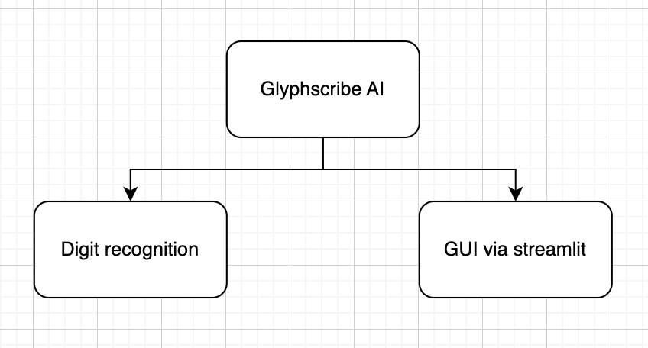
Figure 11 - decomposition diagram 1
Delving deeper into the digit recognition component , we can decompose it further which is shown by the diagram below :
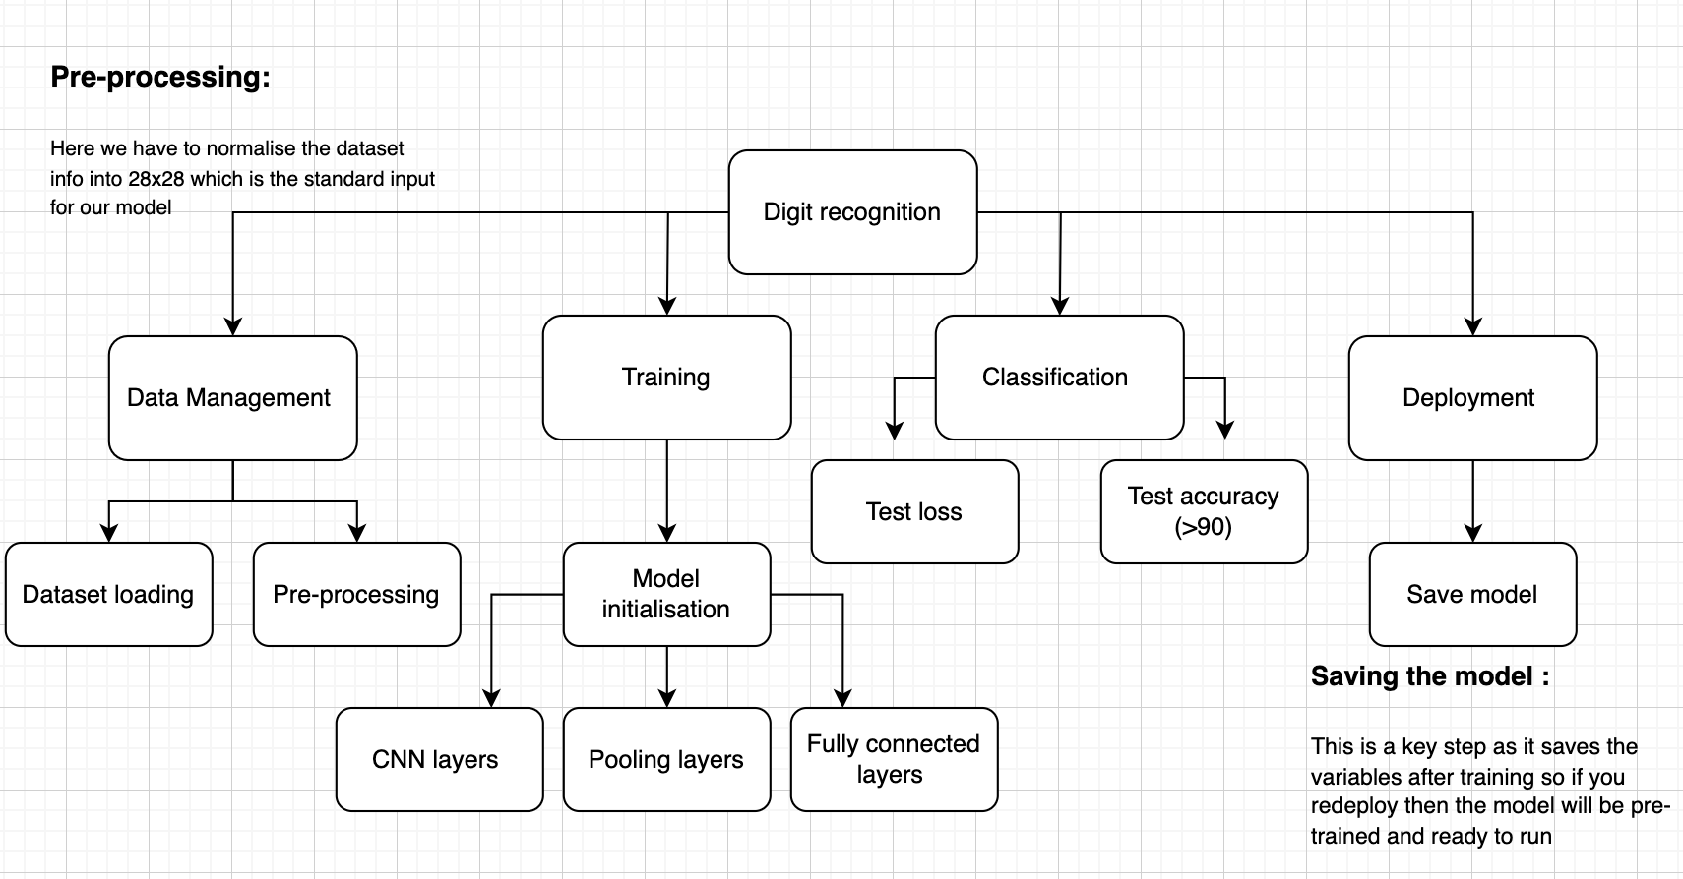
Figure 12 – decomposition diagram 2

Diving deeper into the decomposition I split the project into 2 parts: training and testing the model with the MNIST Dataset and then application of that training to a real- life image of a digit. In Figure 12 I decomposed the larger problem into 4 main chunks:
- Data management :
This describes the processing of data into a format that the model will accept, and convert the inputs (digits from MNIST dataset) into a tensor (multi-dimensional array) that the model can spot patterns with and identify a relationship with the input and output and replicate it when given an unknown example using the function created.

This concern can be separated into two other components: dataset loading and preprocessing. The data loading stage concerns loading the MNIST dataset and reading it using a function. The preprocessing requires turning the input into the required format for the neural network by converting the input image into a tensor representing greyscale values (0-255), this is called normalisation.

- Training
This is where the model’s CNN layers are initialised:
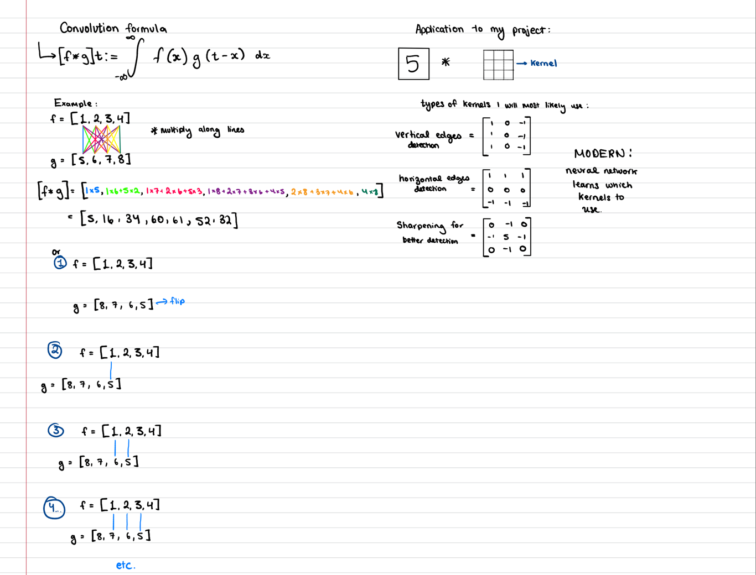
CNN (convolutional layers) – this layer scans input data using the convolutional algorithm :

Pooling layers :
This is another algorithm that down-samples the output of the convolutional layer (feature map), keeping the most important parts and discarding the rest , this reduces the overfitting rate (neural network recognises the digits too well even the noise , which creates unnecessary load on the system ) , to reduce this we have to convolve with max pooling which only picks out the important details with least special resolution.
Fully Connected layer:
This layer is responsible for actually returning an output

- Classification:
This is where I check the accuracy of my code by utilising a loss function for example MAE (Mean Average Error) this tells me the mean distance of the model's prediction away form the ideal when training and testing so that the parameters such as weight and bias can be optimised. I will then test the accuracy of the model after it has been tested.

Defining the Structure:
Referring to the client interview he stated that he wants the theme to be grey and white and based on the questionnaire, it would be ideal to have a home screen. So, I created a mock-up:
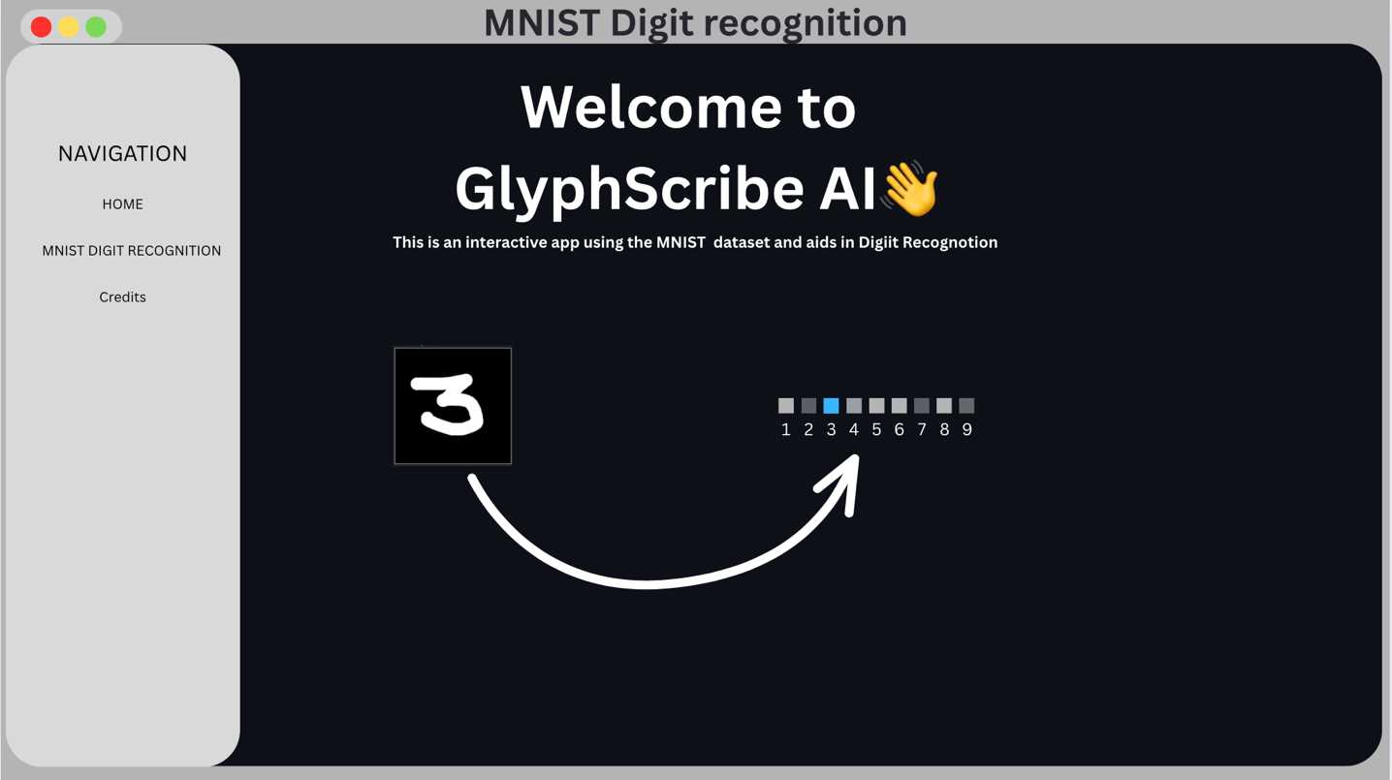

Figure 13 - Home page mock-up

On the left there is a sidebar that is used for navigation and has 3 different sections:
- Home : this the landing page of the program and tells the client a little bit about the program
- MNIST Digit Recognition ( shown below ): this page is where the main program can be interacted with. Here they inset the image as a document and becomes an input to the model (Streamlit in built) and it gives the client the main details that they need, abstracting away the more complex ideas such as hyperparameters which would only be useful for more technical roles and not Dr Kumar . Additionally , there is a high contrast mode which can be toggled on and off from the MNIST Digit recognition screen which makes the application widely accessible to those who have visual impairments.

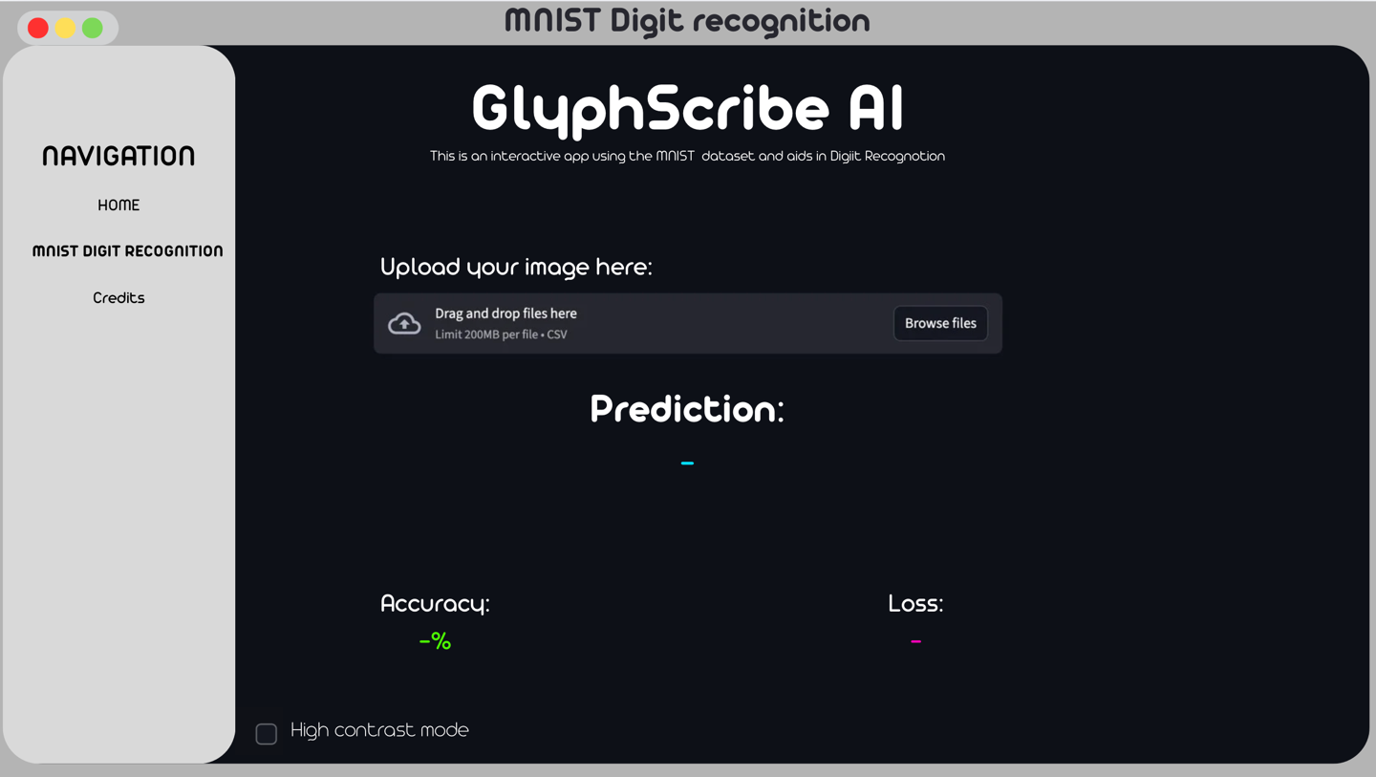

Figure 14 - Main program GUI

Key algorithms:

For this stage I don’t have a dataset so I will create one in order to demonstrate how I will achieve a way of classifying the loss
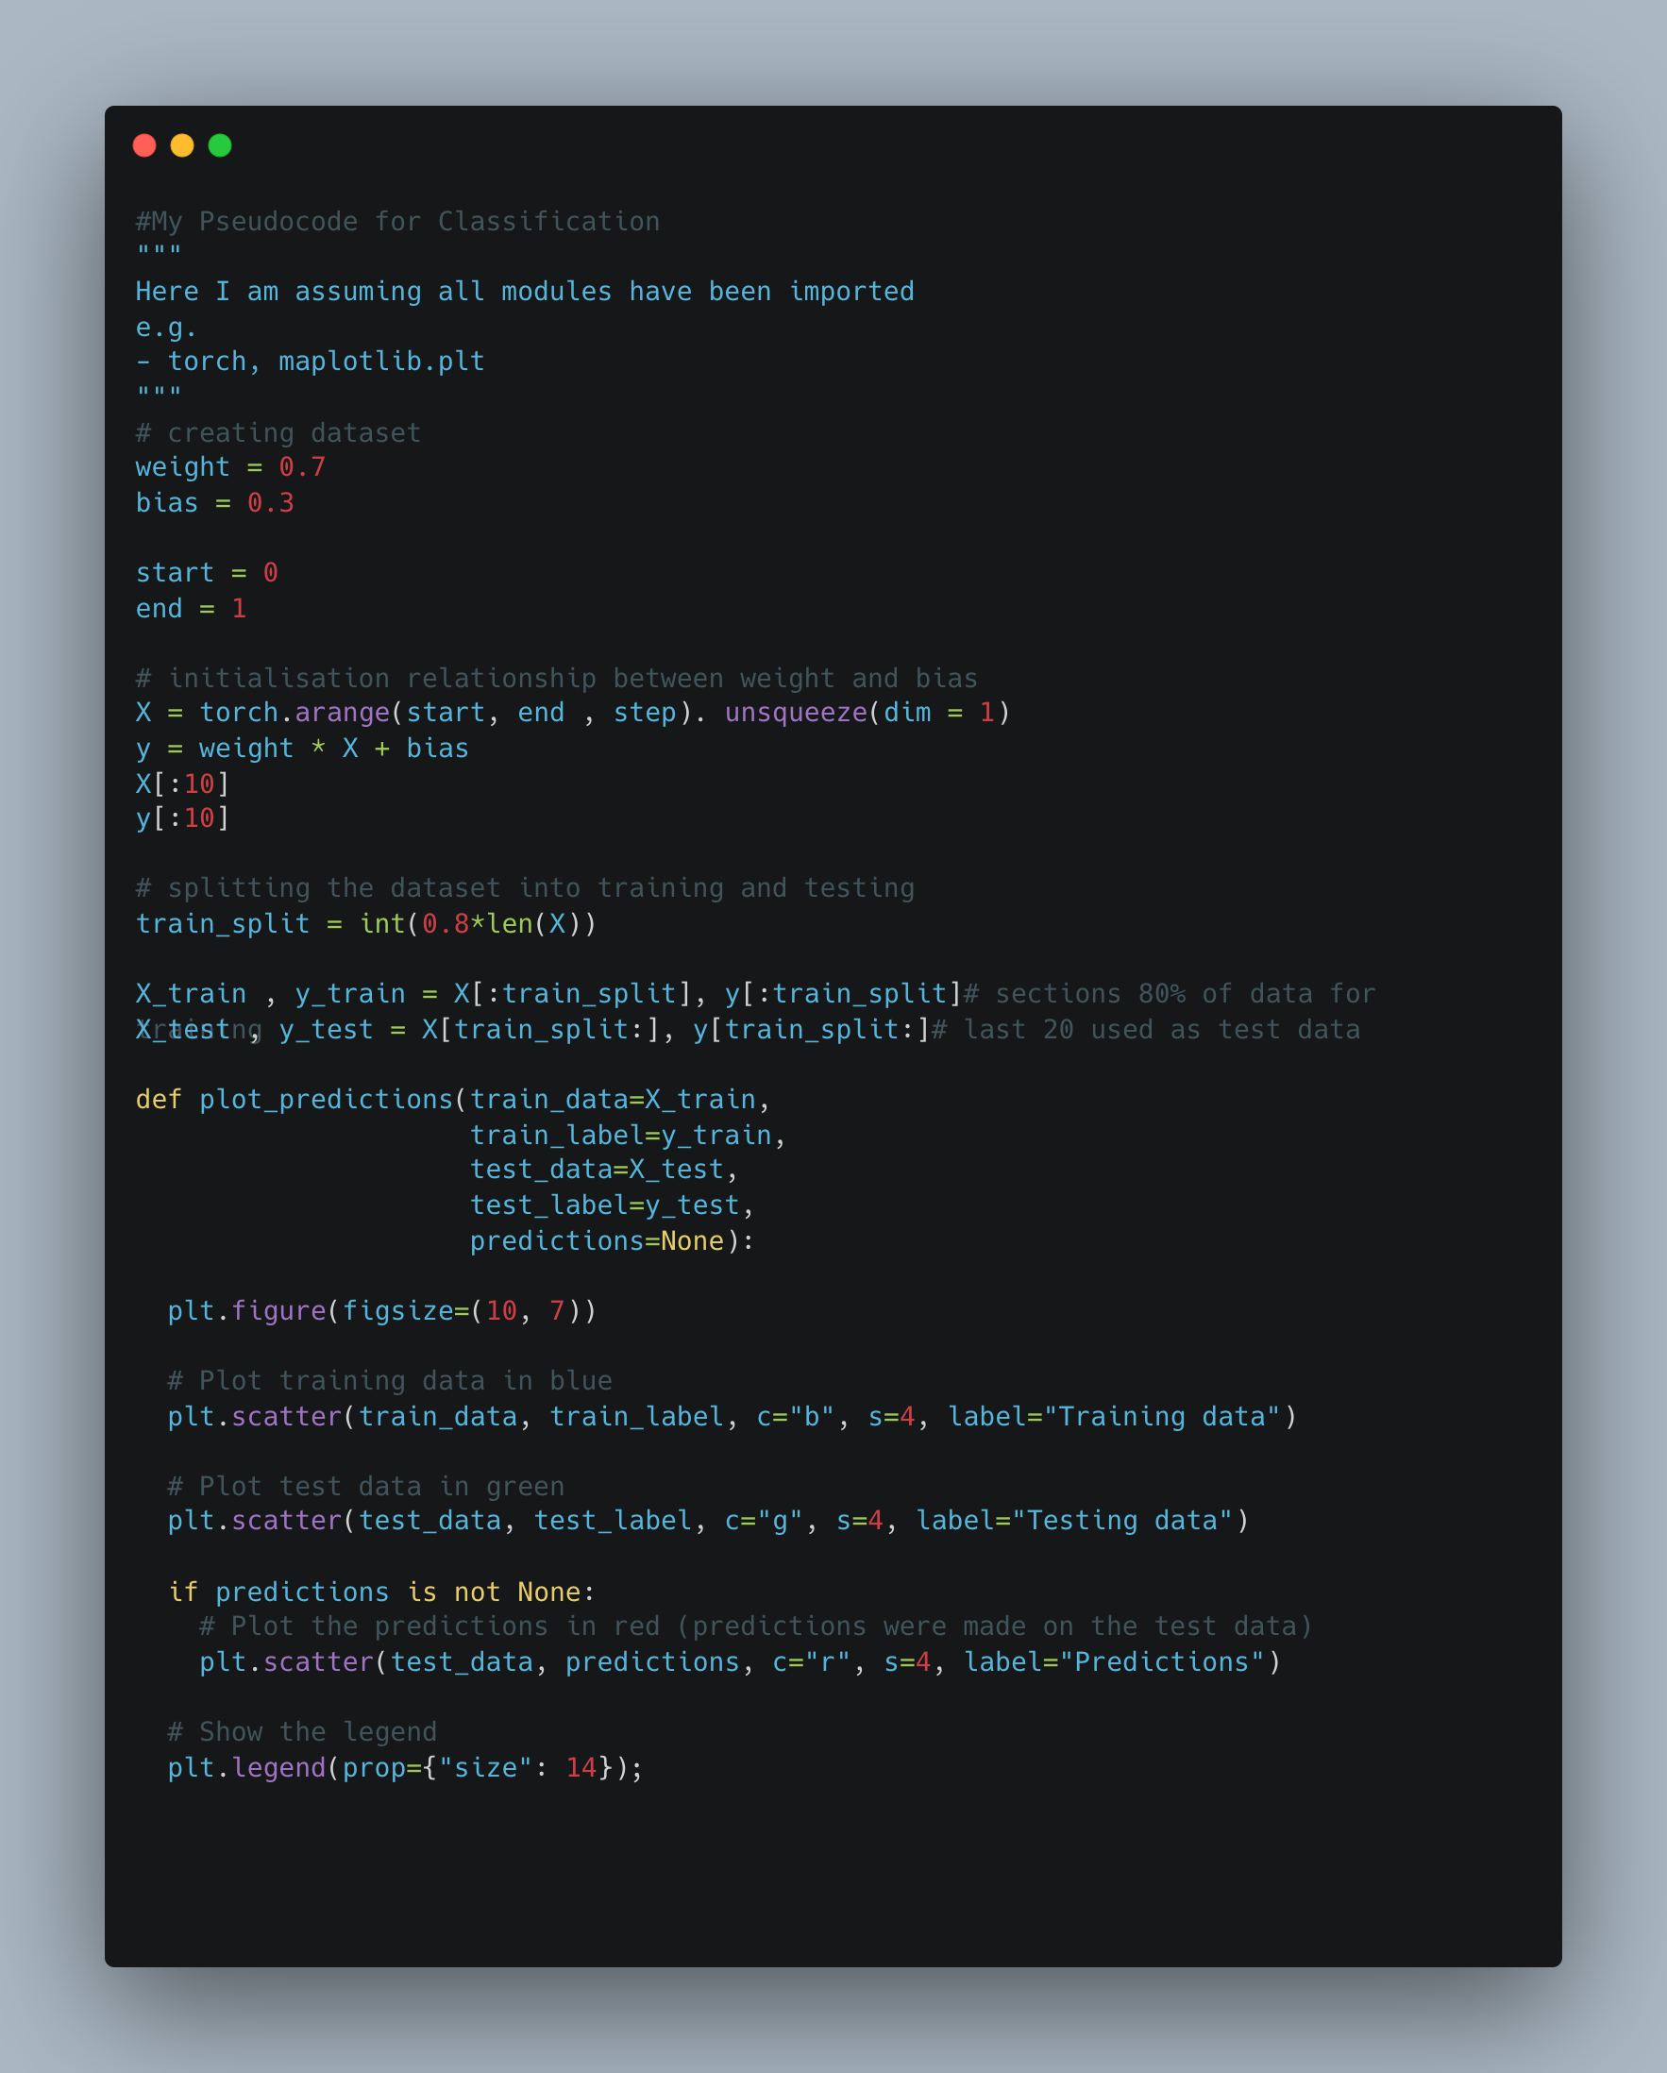

This creates the relationship between the tensor that represents the digits and the number that is outputted and can be plotted with the output of the code above (in reality this already exists):
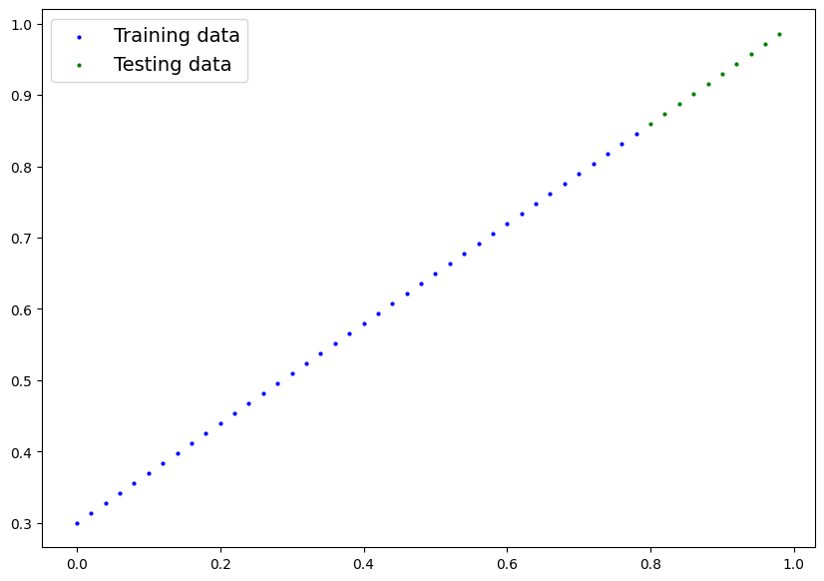

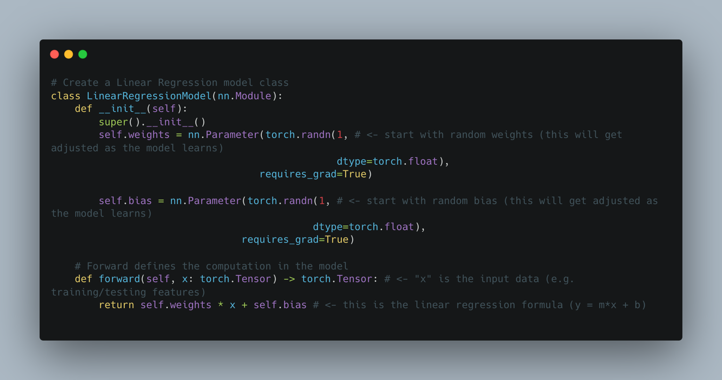
To abstract further I will use a linear regression model at this stage to show the classification aspect:

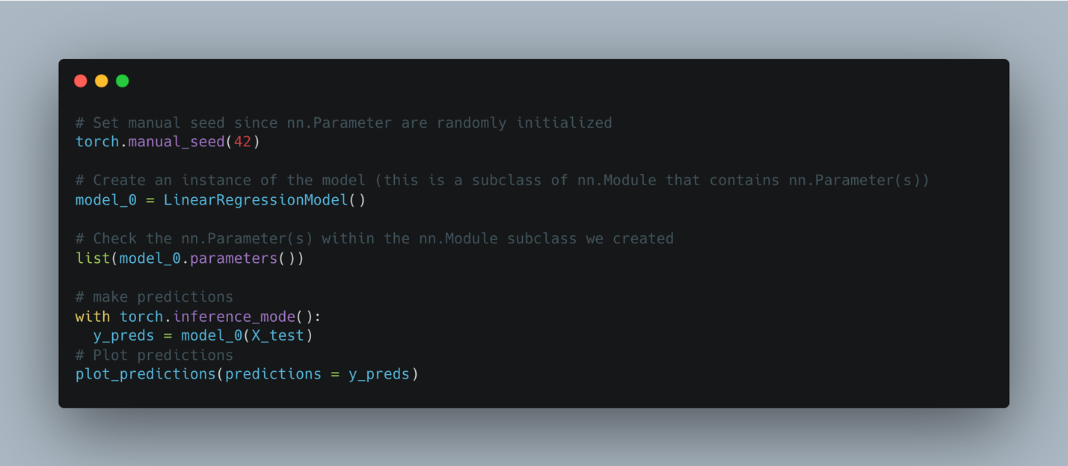

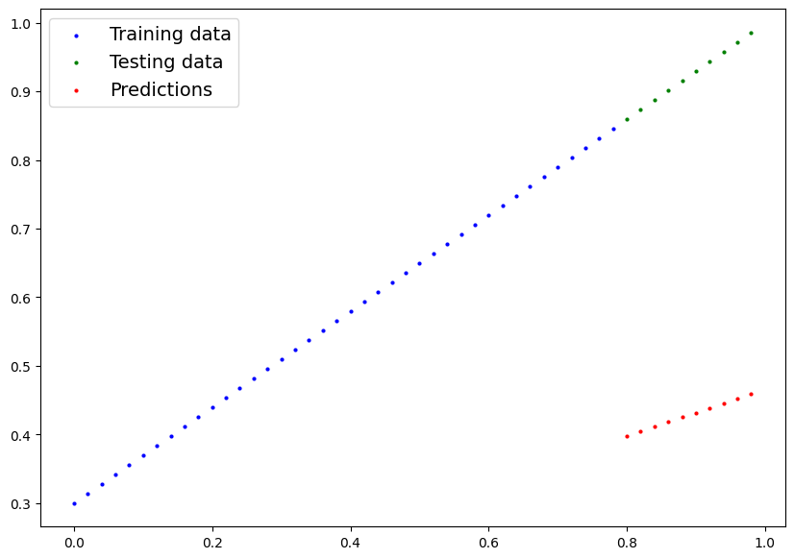

The point of training here is to convert those unknown parameters we started with to known parameters that better represent the correlation of the data. One way to measure and tell your model how wrong its outputs are is by using a loss/cost function(here we use Mean Absolute error – avg. square distance between your parameters and the optimal ones) wher a lower cost is better
The optimiser (torch.optim.SGD) helps us fix this misrepresentation of data by adjusting parameters
Below, I’m using stochastic gradient descent as the optimiser which works by map in the loss as a graph and then finding the minima with calculus ( specifically the chain rule )
Here the hyperparameter ( something we can change ) of lr (learning rate) us used to define the steps towards the optimal solution that the SGD takes (lower lr means that the model will be slower but yield a lower value of cost as a result )

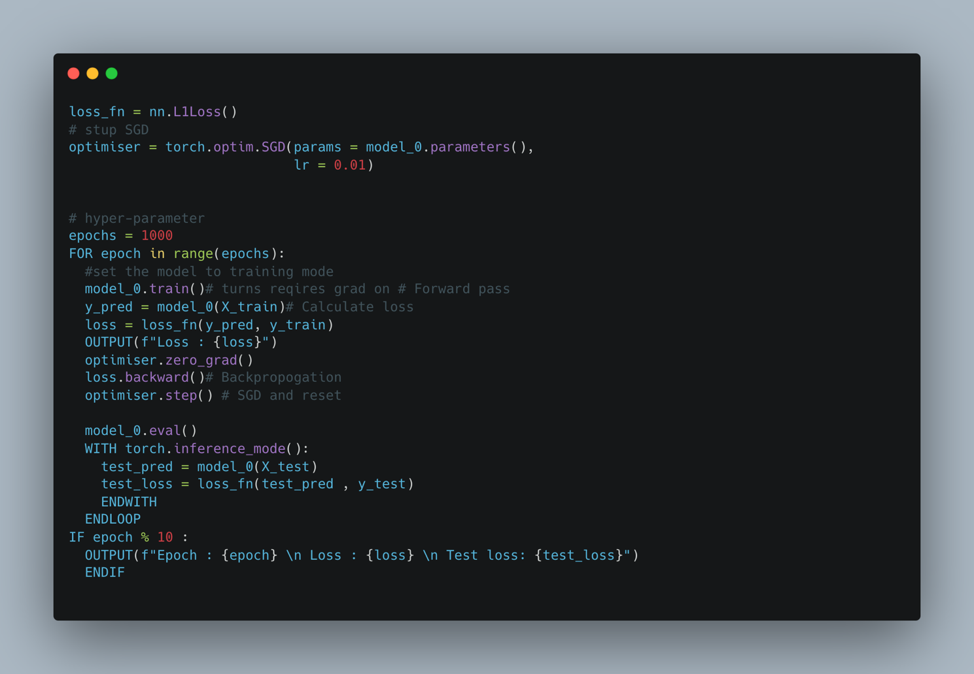

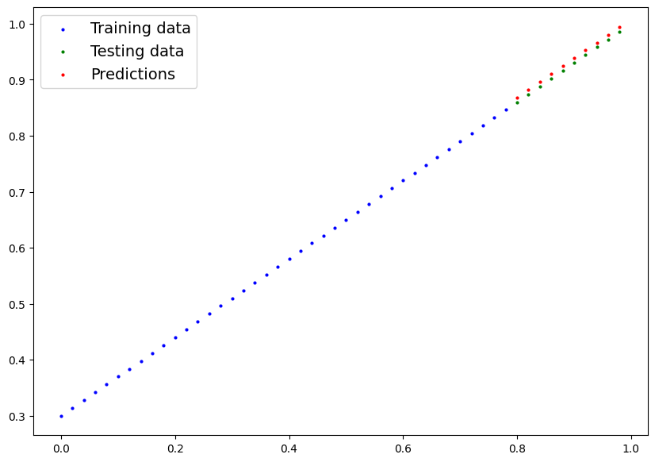
Hence we reduced loss!

Now focusing on the Model initialisation:
- In my actual code the CNN would be made using an inbuilt function but for now I will show how it would be mad using Pseudocode:
Convolutional Layer:
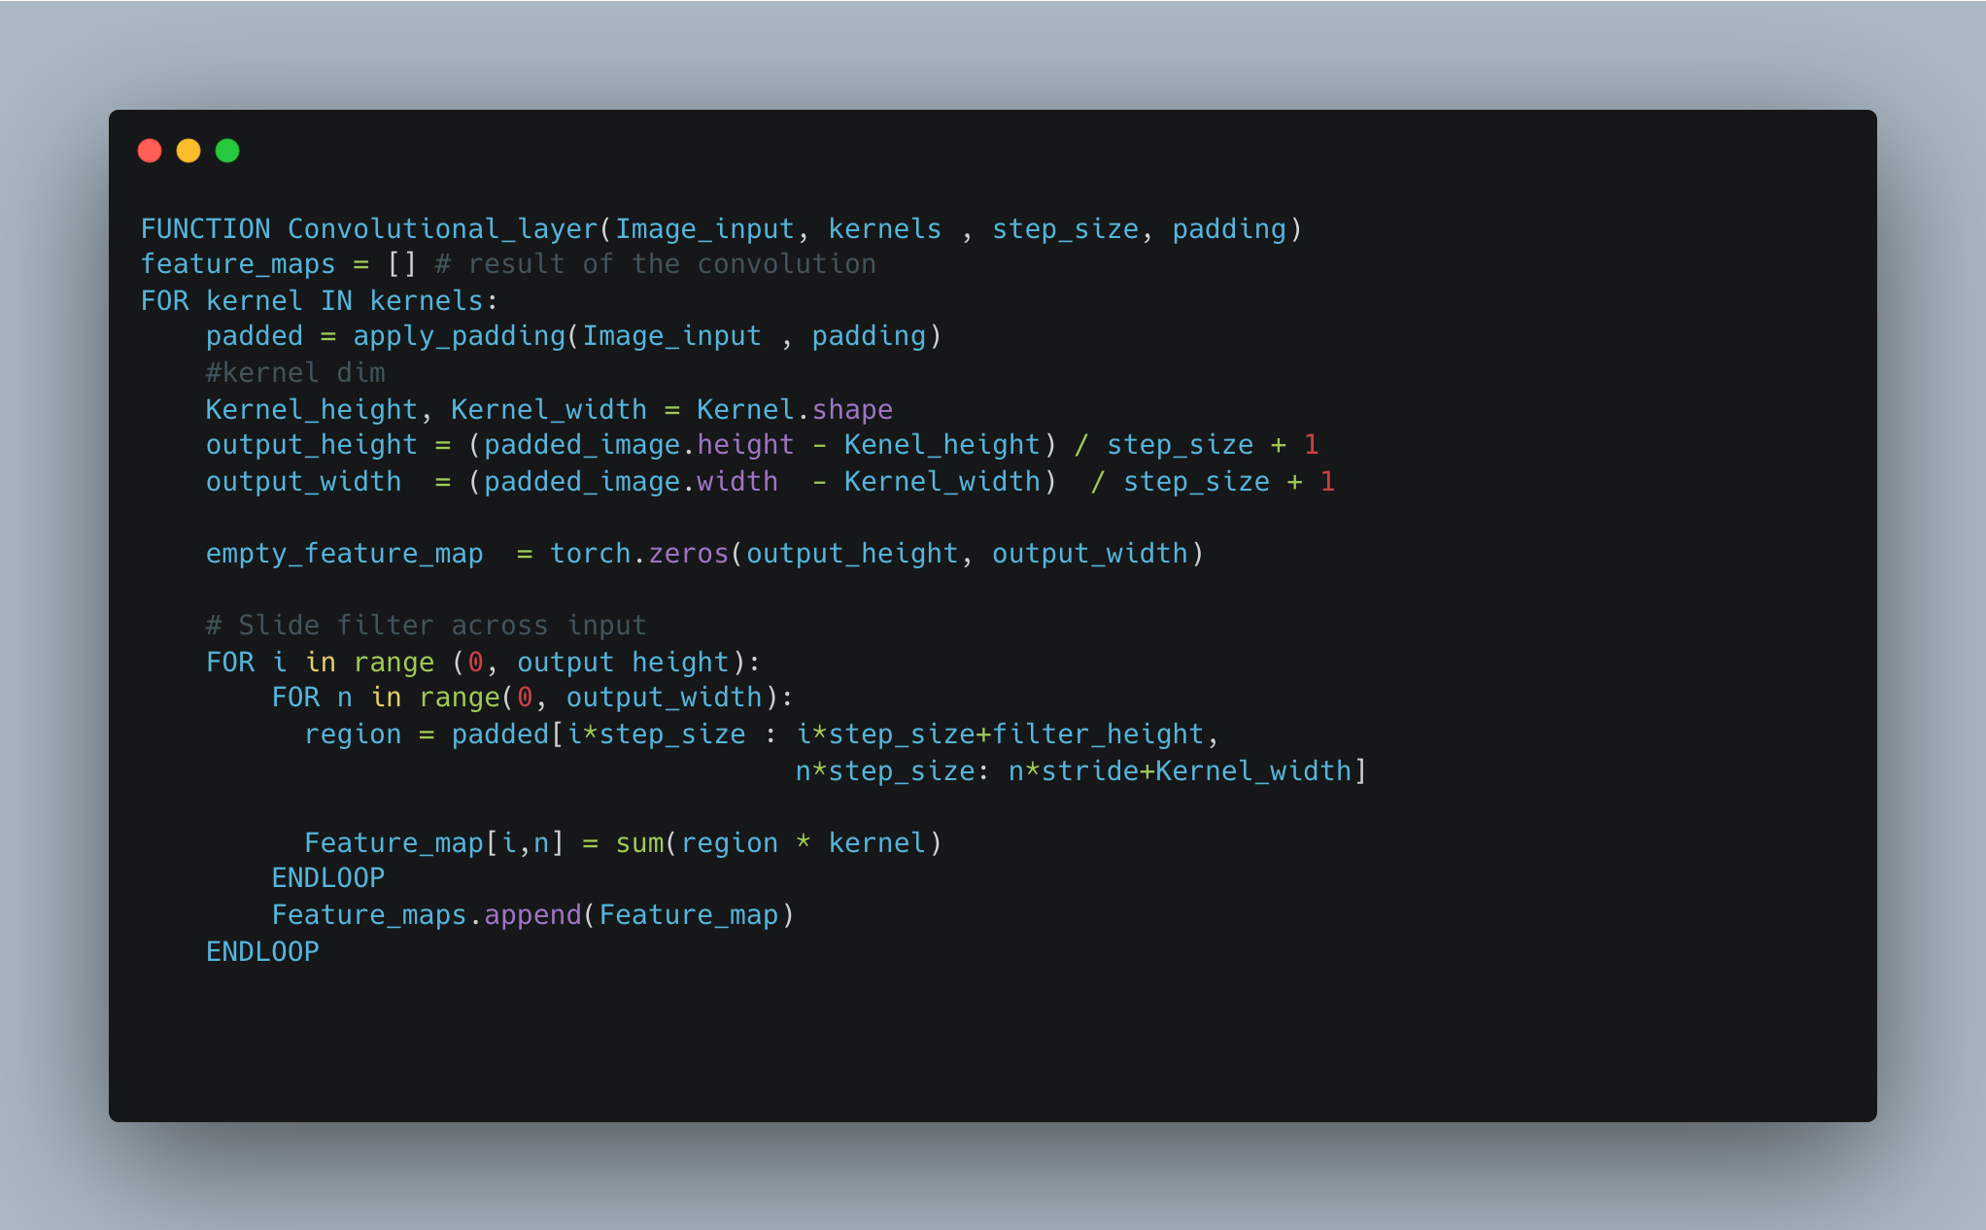
Pooling layer:
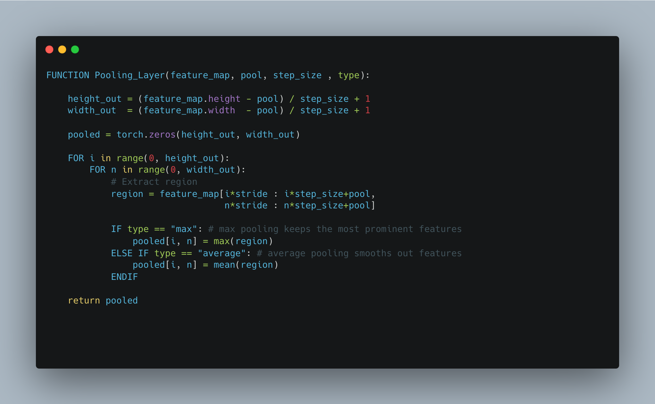

Usability features :
Colours / theme:
Based on the success criteria the theme of the program is a more grey and white based theme and so I implemented that idea in my mock up with a twist of black added to make it more modern and add contrast. This is easily added as it is the default theme within Streamlit.
There is also a button to change the theme to a even more contrasting colour theme and a thicker font.
Page System:
To allow for easy navigation of the pages I introduced the sidebar system (which can also be implemented within Streamlit) this is where you can switch between the home page and the page with the ML inbuilt and makes sure that the space isn’t too cluttered and so will not overwhelm the clients initially.
Digit recognition :
To aid the client I added a drag and drop system for the input file which makes it much easier for the client to upload their files or browse their computer for them.
I also added the main statistics for the model that would be useful for the client such as the loss and the accuracy that was reached by the end of the model running, this is displayed clearly in vivid colours below the result of the program.
Font :
At this is stage there is no preference for the font , but is should be clean and minimal to reflect the design of the page.

Key Variables, sub programs and classes
Classes:
Type | Name | Description
Class | Network | A class for the layers of the CNN and will transform a tensor in the forwards pass
Class | Regression model | A class for the weight and bias to be instantiated
Class | Evaluator | A class to test accuracy

Sub programs:
Type | Name | Description
Sub- program | Load_data | Function that returns the dataset
Sub- program | Normalise | Function that returns the pre-processed data that has been made a viable input to the model
Sub- program | Data_split | Splits the dataset into training ad testing split (usually 80-20)
Sub- program | One_hot_encode | Function that returns the input as a tensor
Sub- program | Show_prediction | Procedure that returns the output in the GUI
Sub- program | Save_model | Procedure that saves the model’s state dictionary as a .pth to be once trained
Sub- program | Predict_digit | Funciton that returns the predicted digit
Sub- program | Plot_metrics | Function that returns the plotted graph to visualise the result

Variables:
Type | Name | Description
List variable | Y_train | Training labels
Image variable | X_train | Images from dataset
Tensor variable | x_train | Normalised data after preprocessing
Tensor variable | X_test | Tensor containing the reshaped data
Constant | shape | Shape of the input (28x28)
hyperparameter | Learning rate | The step in SGD towards minimal loss
Float variable | Dropout rate | Proportion of data dropped when pooling
Tensor variable | Kernel_size | Tensor with the shape of the kernel
Float variable | Loss | Lower the better the model is at predicting
Float variable | Accuracy | Tells us how accurate the model is
.pth file | Model_name | Location that the parameters of the file are stored in

Testing
Broad context | Context | Test | Input type | Expected result
Sidebar | Home button | Click button | normal | Goes to home page
 |  | Click nothing | erroneous | Nothing happens
 |  | Click any keyboard key | erroneous | Nothing happens
 | MNIST digit recognition button | Click button | normal | Goes to home page
 |  | Click nothing | erroneous | Nothing happens
 |  | Click any keyboard key | erroneous | Nothing happens
MNIST digit recognition page |  | Attach unsupported file format | erroneous | Outputs error notification
 |  | Attach MNIST dataset image | Normal | Outputs correct number predication
 |  | Attach valid image | Normal | Outputs number prediction , loss and accuracy
 |  | Attach blurry image | Boundary | Outputs blurry image error

Backend Testing :
Testing | Checking for
Preprocessing occurs correctly | Converted into 28x28
Training and test split occurred correctly in training | 80/20 split of MNIST
Loss decreases over many epochs | Verify that the model finds optimal parameters
Too much overfitting | Noise recognised
Digits stored in excel file for future | Digits in excel file

